ARTIFICIAL INTELLIGENCE



submitted by:

K Jaswanth (37)

Sanskar poudel (38)

N Rudreswar (39)

Santra Suvasree (40)

Topics:

->Introduction:

->Abstract

->Approch

->Dataset description

->Output

->Conclusion

Introduction:

This project is help to shortlist the candidates from a large number of cv’s. It includes the personality based questions and aptitude questions.

Abstract:

In this project we have used Algorithms and data mining concepts to analyze the individual data . this projects helps us to when we have large amount of personal behavioral data.This data can be helpful

To classify persons using automated personality prediction .

Approach:

Five characteristics of different individuals commonly known as openness ,neuroticism,conscientiousness,agreeable-ness and extraversion are stored in a dataset and used for training.Based on this testing the personality is predicted.It is pre-processeed using different data mining values,data discretization,normalization etc.

And finally system analyzes the person cha-racteristics and behaviours. System then predicts new user data stored by classification of previous user data.

Dataset description:

|  |  |  |  |
| --- | --- | --- | --- |
| S.NO | ATTRIBUTE | TYPE | RANGE |
| 1 | gender | nominal | male/  female |
| 2 | age | numeric | 17-28 |
| 3 | openness | numeric | 1-8 |
| 4 | neuroticism | numeric | 1-8 |
| 5 | conscientiousness | numeric | 1-8 |
| 6 | agreeableness | numeric | 1-8 |
| 7 | extraversion | numeric | 1-8 |

Output :

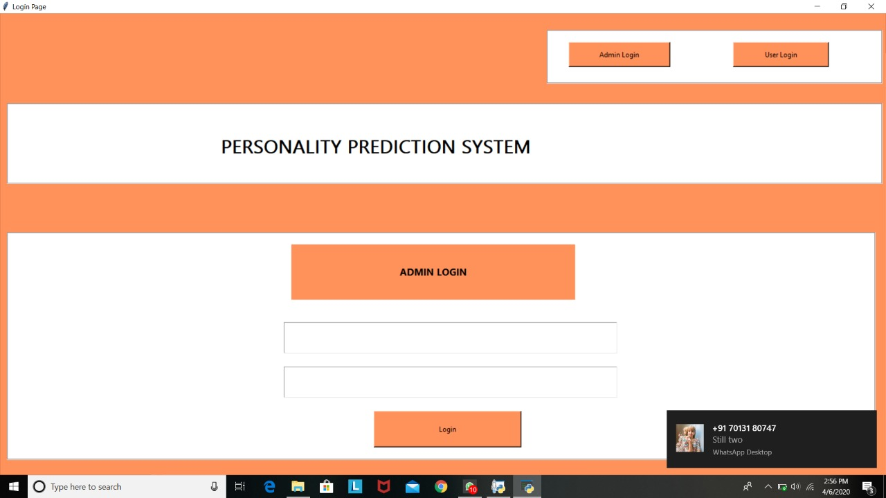

Here the user get the details for his mobile to log on to the website to fill the CV.

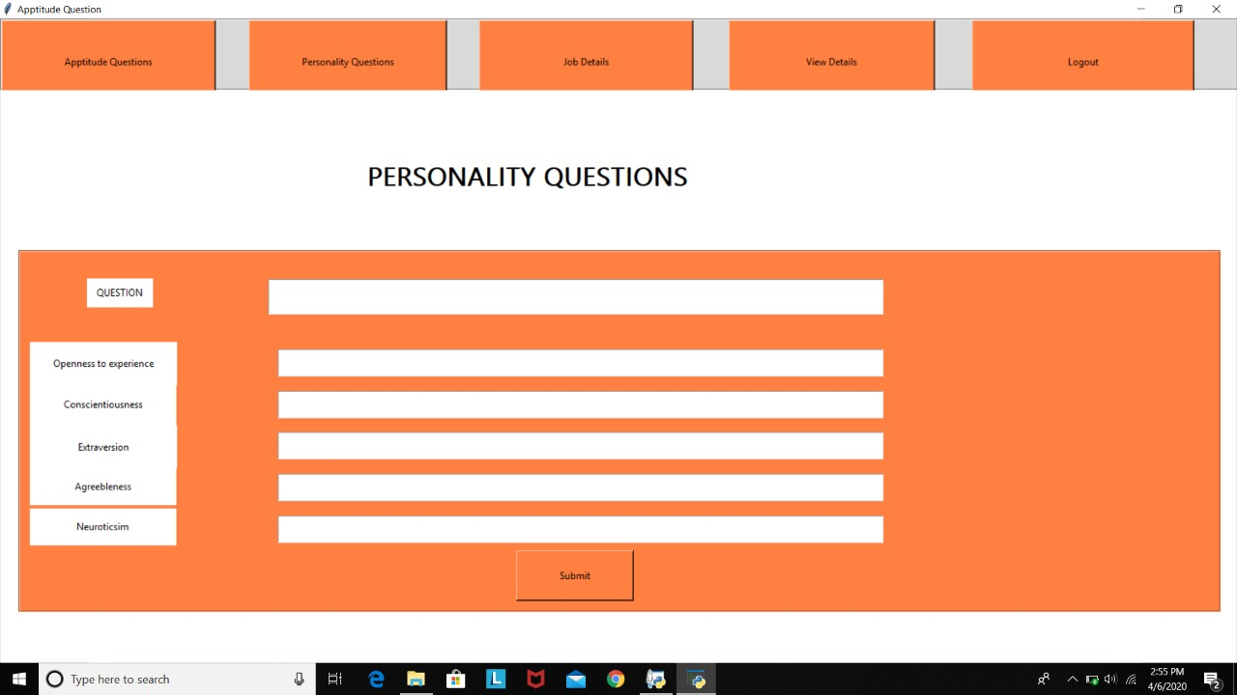

Here the admin gives the question on the top of the dialog box . So the user below get the five options to choose one answer each given to them.After the completion the user has to submit so following data will be added to the database.So the user get the next module Aptitude questions.

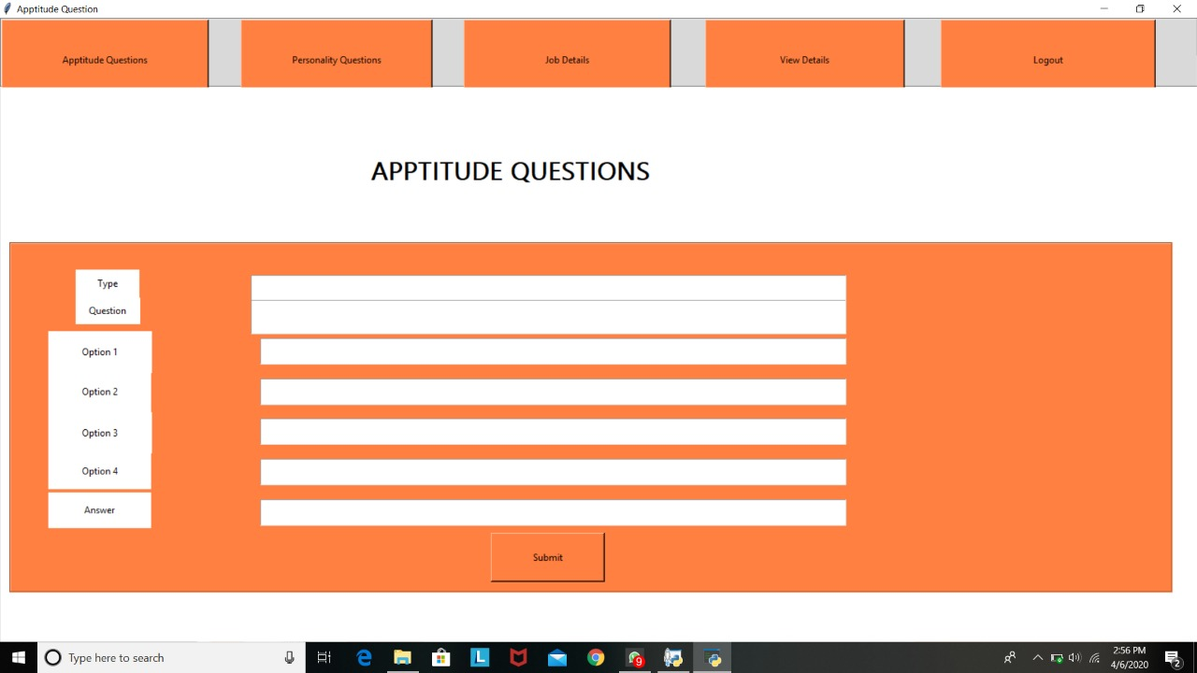

After getting this module now the user go to aptitude based questions same as the personality questions the user has to submit every option given to him.After this module the user get job details module now he has to give the details of his preffered job which sector he is interested to work in

And for what package he gonna do this etc.

After filling every details he has to submit this page and data will be saved to database.Has everything completed now user can view his every module details in single page.Further cross checking he will submit the details.

Conclsion:

This will enable a more effective way to shortlist the submitted candidates CV from a large number of applicants providing a consistent and fair CV ranking policy,which can be legally justified. System the will rank the experience and key skills for a particular person. This Predictions system helps in many industries to select the right candidate for their work